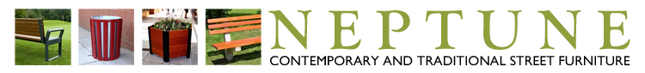
75 x 1800mm Amber Stained RAL 8001 Hardwood
YOUR TEXT HERE UP TO 30 CHARACTERS
YOU CAN TYPE YOUR TEXT
HERE ALLOWING FOR UP TO
50 CHARACTERS

